**Individual** [**e-Portfolio**](https://vasilisalook.github.io/)**: Reflective Part (1000 words)**

**(Research Methods and Professional Practice May 2023)**

**To be a science communicator or not**

Before starting this module, my goal as a journalist, rather than an IT specialist, was to become a science communicator in the field of Artificial Intelligence. (Trench, 2017). To effectively convey information in a complex and abstract field like AI, it is important to possess the ability to create engaging stories, provide visual illustrations, and communicate confidently with the target audience (Carillo-Zapata, 2022).

However, I realised that my level of expertise in this field is limited yet.

Banoula (2023) pointed out that it typically takes a year to become an AI engineer. Nevertheless, in addition to communication skills and problem-solving abilities it is also crucial to acquire programming skills, to possess domain expertise in the specific field and critical thinking abilities. At the same time, modern AI technologies can assist in the development of various skills, including critical thinking. (Rusandi et al., 2023).

**Critical thinking**

I had a valuable learning experience from my failure in the Literature Review Assignment during this module. Firstly, I recognised my weakness in rephrasing. Secondly, I understood the importance of learning about critical thinking in an academic context (Klimova, 2013), which differs from journalistic criticism of the government.

Critical thinking is one of the crucial “4C” skills in the 21st century, along with communication, collaboration, and creativity (Spector & Ma, 2019).

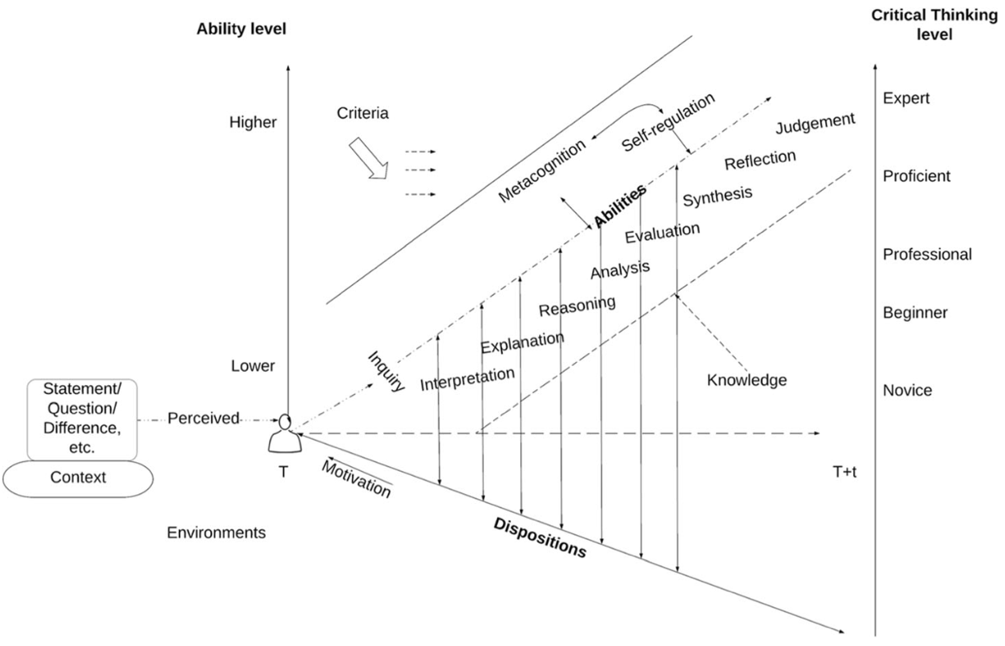

*Illustration 1. A framework of critical thinking (Spector & Ma, 2019)*

However, the traditional educational approach of "doing what is told" may result in students losing interest in the material and inhibiting the development of critical thinking. Additionally, summarising and paraphrasing can be challenging, particularly for those who are non-native English speakers (Ibna Seraj & Oteir, 2022).

From a theoretical point of view, writing entails the process of actively engaging in critical thinking and serves as a medium for conveying the outcomes of that critical thinking (Ideas, 2011). On a practical level, McKinsey experts provide a different perspective on critical thinking, describing it as the desired level of proficiency wherein individuals can effectively tackle complex problems by breaking them down into parts, identifying root causes for each part, and finding appropriate solutions (Dondi et al., 2021).

**Scholars also lie**

Prior to this module, my understanding of ethics was primarily focused on journalistic ethics, if it exists (McBride & Rosenstiel, 2013). However, here we explored ethics from various perspectives, ranging from the issue I raised about the lack of scientific articles on AI and weapons (Lukashevich, 2023d) to unethical behaviour among researchers (Lukashevich, 2023c), including the manipulative surveys (in the illustration below). The main takeaway, in short, is that scientists can also engage in deception — we should re-evaluate research findings (Gerwing et al., 2021).

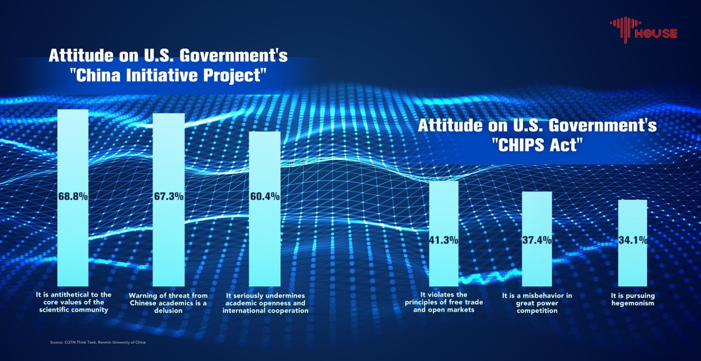

**Research Proposal Presentation**

In contrast to the Literature Review, I had complete freedom in choosing the topic, which resulted in my higher level of involvement. It might be more suitable, instead or along with the Outline, to incorporate student self-assessment for the tasks (Jacobs, 2014).

For this quantitative research relying on numerical data (Creswell, 2017), it was an obvious decision to commence the presentation with a T-test of two samples. However, as the analysis progresses, it would be prudent to consider incorporating correlation coefficients and regression statistical techniques (Hoare & Hoe, 2013).

Additionally, that both tools being researched provide not only numerical data but also textual and even graphical output. Given my integration into the journalist community, there is potential to expand the research using mixed methods, as suggested by Onwuegbuzie and Teddlie (2003).

**Delving in Statistics**

We had a statistical worksheet exercise in this module, which was timely in refreshing my knowledge from the Numerous Analyses Module before the capstone project. Initially I didn’t grasp the significance of the F-Test for Equality of Two Variances. Upon reading the literature, I discovered that before comparing means of two groups, it is important to ensure that the data values are independent, randomly sampled, and the two independent groups have equal variances, otherwise it can lead to errors in rejecting the correct null hypothesis — type I error. (Keselman et al., 2004). However, utilising the default option in R — t.test — we may always run a Welch's t-test, which does not assume homogeneity of variance. Some scholars propose by default use Welch's t-test instead of Student's t-test (Delacre at al., 2017). Also I need in-depth statistical understanding for my final project at the university.

**The big ladder of apps**

In my academic journey, I envision myself climbing from one module to another, ultimately diving into the lake of the capstone project. Each module brings a fresh set of applications, although my picture below does not show the complete list. While I was familiar with some apps previously and improved my user skills, most of them were entirely new to me. Ironically, AI-based apps, like ChatGPT, aid in my understanding of AI. [Its coding ability surpasses mine](https://vasilisalook.github.io/practice/2023/04/15/3-3.html). However, I realised a fundamental characteristic of contemporary artificial intelligence – AI is designed to mimic human intelligence in decision-making, image recognition, translation, churning out text and images (Mazzone & Elgammal, 2019). Nevertheless, it is unable to create something entirely novel. Additionally, AI models encounter challenges in transferring their experiences across different contexts (Chui et al., 2018).

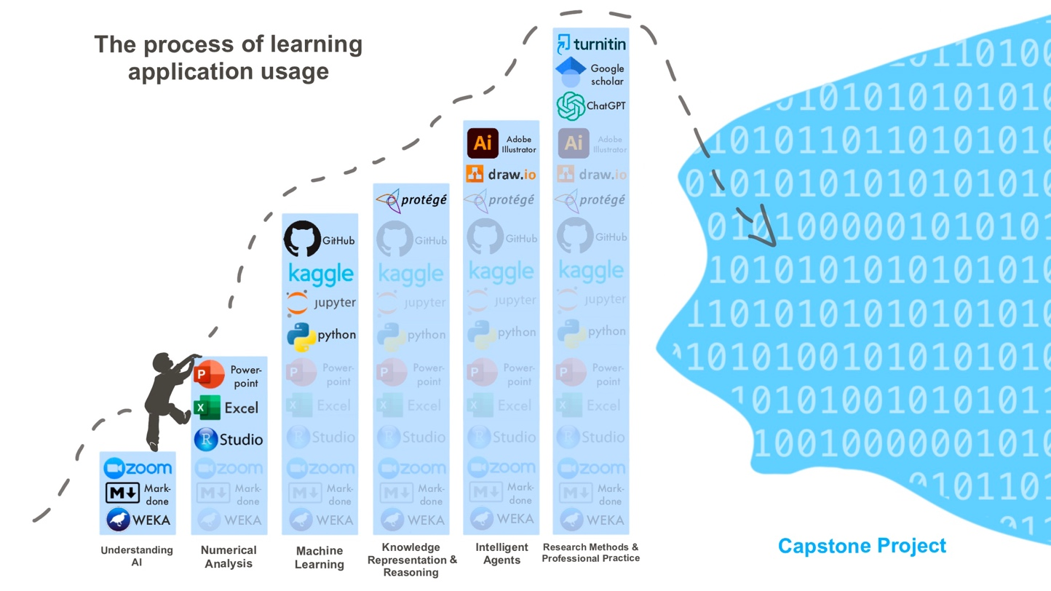

*Illustration 2. My study journey from an applications standpoint*

**Plan for taking the learning forward**

Through a thorough examination of McKinsey's research on the 56 foundational skills for the future of work, I have assessed my own strengths and weaknesses (Dondi et al., 2021). You are welcome to review some of them in the SWOT file. As outlined in my Action Plan, some of my current goals are to obtain a Scrum Master certification and subsequently join an AI project team with greater confidence. The Scrum Master plays a crucial role in coaching, motivating, and mentoring the team, acting as a guardian of the project to ensure its timely completion, improved quality, and reduced stress for team members (Ereiz & Mušić, 2019). However, I am aware of the potential risk associated with my limited coding experience, as it may place me at a disadvantageous position resembling that of an inexperienced individual with only a general understanding of the project (Bolloju et al., 2018).

Here, the main reflections were presented, while in the "Individual e-Portfolio. 12 Units," I have compiled all the artefacts, practices, discussions, and some notes for each unit. Additionally, the extended versions of the work for each unit are included in additional files.

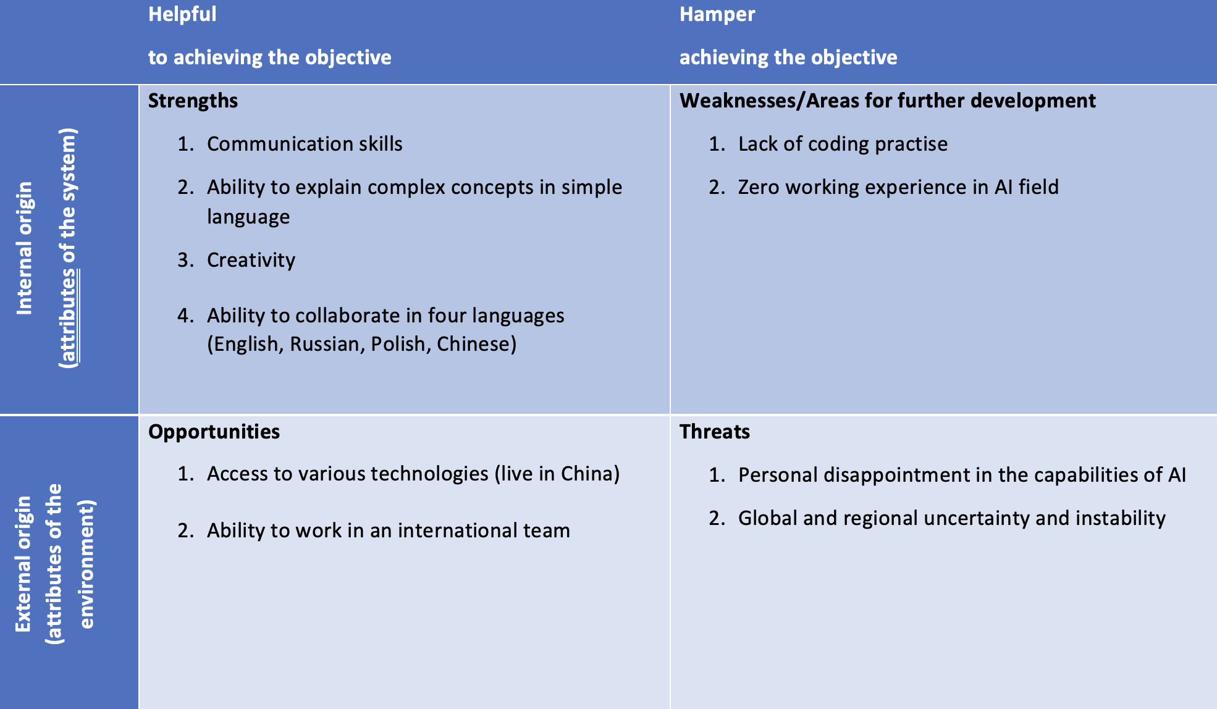

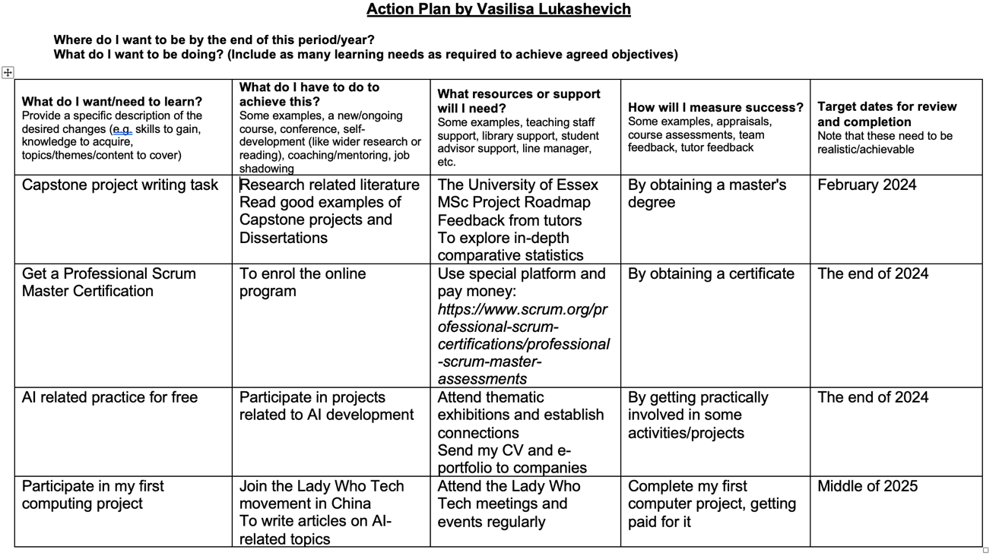

**References**

Banoula, M. (2023) How to Become an Artificial Intelligence (AI) Engineer in 2023? Available from: https://www.simplilearn.com/tutorials/artificial-intelligence-tutorial/how-to-become-an-ai-engineer [Accessed 16 Jul 2023]

Bolloju, N., Chawla, R. & Ranjan, R. (2018) Pros and Cons of Rotating Scrum Master Role: A Qualitative Study. In *Proceedings of the 11th Innovations in Software Engineering Conference* (pp. 1-5).

Carillo-Zapata, D. (2022) How to approach the media: An interview with Evan Ackerman (Senior Editor at IEEE Spectrum). Available from: https://www.youtube.com/watch?v=5kslhRzoDRw [Accessed 16 Jul 2023]

Chui, M., Manyika, J. & Miremadi, M. (2018) What AI can and can’t do (yet) for your business. *McKinsey Quarterly,* 1(97-108), p.1.

Creswell, J.W. & Creswell, J.D. (2017) Research design: Qualitative, quantitative, and mixed methods approaches. Sage publications.

Delacre, M., Lakens, D. & Leys, C. (2017) Why psychologists should by default use Welch's t-test instead of Student's t-test. *International Review of Social Psychology, 30(*1), pp.92-101.

Dondi, M., Klier, J., Panier, F. & Schubert, J. (2021) Defining the skills citizens will need in the future world of work. *McKinsey & Company, 25*.

Ereiz, Z. & Mušić, D. (2019) Scrum without a scrum master. In *2019 IEEE International Conference on Computer Science and Educational Informatization (CSEI)* (pp. 325-328). IEEE.

Gerwing, T.G., Allen Gerwing, A.M., Choi, C.Y., Avery-Gomm, S., Clements, J.C. & Rash, J.A. (2021) Re-evaluation of solutions to the problem of unprofessionalism in peer review. *Research Integrity and Peer Review, 6*(1), pp.1-5.

Hoare, Z. & Hoe, J. (2013) Understanding quantitative research: Part 2. *Nursing Standard, 27*(18), pp.48-55.

Ideas, E. (2011) The Professor's Guide to Integrating Writing, Critical Thinking, and Active Learning in the Classroom.

Jacobs, P. (2014) Engaging Students in Online Courses. *Research in Higher Education Journal, 26.*

Keselman, H.J., Othman, A.R., Wilcox, R.R. & Fradette, K. (2004) The new and improved two-sample t test. *Psychological Science, 15*(1), pp.47-51.

Klimova, B.F (2013) Developing thinking skills in the course of academic writing. *Procedia-Social and Behavioral Sciences, 93*, pp.508-511.

Lukashevich, V. (2023a) A journey of a thousand exabytes. MSc AI E-Portfolio. Available from: https://vasilisalook.github.io/ [Accessed 14 Jul 2023]

Lukashevich, V. (2023b) ChatGPT created a working code for my special schedule. Available from: https://vasilisalook.github.io/practice/2023/04/15/3-3.html [Accessed 14 Jul 2023]

Lukashevich, V. (2023c) Initial post: Evidence is in the details. [Collaborative Learning Discussion 2]. Research Methods and Professional Practice May 2023. University of Essex Online. Available from: https://www.my-course.co.uk/mod/forum/discuss.php?d=165964 [Accessed 8 Jul 2023].

Lukashevich, V. (2023d) Initial Post: Weapons and ethics [Collaborative Learning Discussion 1]. Research Methods and Professional Practice May 2023. University of Essex Online. Available from: https://www.my-course.co.uk/mod/forum/discuss.php?d=156259 [Accessed 17 Jul 2023].

Mazzone, M. & Elgammal, A. (2019) Art, creativity, and the potential of artificial intelligence. In Arts (Vol. 8, No. 1, p. 26). MDPI.

McBride, K. & Rosenstiel, T. eds. (2013) The new ethics of journalism: Principles for the 21st century. CQ Press.

Onwuegbuzie, A.J. & Teddlie, C. (2003) A framework for analyzing data in mixed methods research. Handbook of mixed methods in social and behavioral research, 2(1), pp.397-430.

Rusandi, M.A., Ahman, Saripah, I., Khairun, D.Y. & Mutmainnah (2023) No worries with ChatGPT: building bridges between artificial intelligence and education with critical thinking soft skills. *Journal of Public Health*, p.fdad049.

Spector, J.M. & Ma, S. (2019) Inquiry and critical thinking skills for the next generation: from artificial intelligence back to human intelligence. *Smart Learning Environments, 6*(1), pp.1-11.

T-House (2022) A CGTN Think Tank survey in American Global Tech Bullying [Twitter] 26 Dec. Available from: https://twitter.com/thouse_opinions/status/1607264309675167746?s=46&t=NCEj2ikp-R_duBDE0wXE6Q [Accessed 10 Jul 2023]

Trench, B (2017) Universities, science communication and professionalism. *Journal of Science Communication, 16*(5), p.C02.